H.T No
Regulations:
A15


Sreenidhi Institute of Science and Technology
(An Autonomous Institution)
Code No: 5CC57 Date: 28-May-2019 (AN)

B.Tech III-Year I-Semester External Examination, May/June-2019 (Supplementary)
FUNDAMENTALS OF SIGNALS AND SYSTEMS (EEE)

Time: 3 Hours Max.Marks:75

Note: a) No additional answer sheets will be provided.
b) All sub-parts of a question must be answered at one place only, otherwise it will not be valued.
c) Missing data can be assumed suitably.

Part - A Max.Marks:25

Answer all QUESTIONS.

1. | Define Signum function and list out the properties of Signum function. | [3M]
2. | Define Hilbert transform and explain the significance of Hilbert transform | [3M]
3. | State Paley-Wiener criterion and state the conclusions drawn the criterion. | [3M]
4. | Define unit Ramp function and find its Laplace transform. | [3M]
5. | What is aliasing and how it can be eliminated? | [3M]
6. | State and prove linearity property of Z transform. | [2M]
7. | Distinguish between even and odd signals. | [2M]
8. | Explain the difference between Signal Band width and System Band width. | [2M]
9. | Define Z transform. | [2M]
10. | Find the Fourier transform of an impulse signal. | [2M]
Part – B Max.Marks:50
ANSWER ANY FIVE QUESTIONS. EACH QUESTION CARRIES 10 MARKS.

11. | a) | Determine whether the following signals are periodic/ Aperiodic, Energy/Power and hence find period, energy/power  i). x₁(t) = sin12πt, ii). x₂(t) = e^{j4πt} | [4M]
 | b) | What is Orthogonality? Show that the function f(t) is orthogonal to signals  cost, cos2t, cos3t,….. cosnt for all integer values of n over the interval 0 to 2π, if  f(t) = 1 0 ≤ t ≤ π  = -1 π ≤ t ≤ 2π | [6M]
12. | a) | Find the Trigonometric Fourier Series of the below signal.  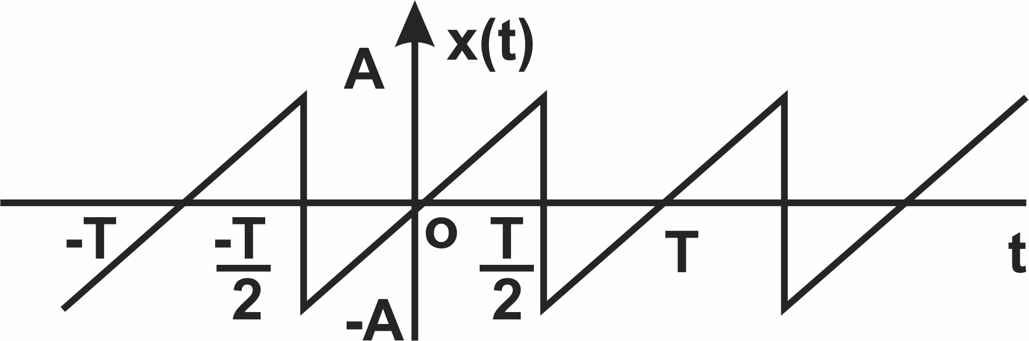 | [6M]
 | b) | Compute the Fourier Transform of the following signals and draw the spectrum  i). x₁(t) = e^{-at} u(t)  ii). x₂ (t) = __1___  a² + t² | [4M]
13. | a) | What is Distortionless transmission system? show that for a linear phase system the impulse response is symmetrical about delay and is non causal. | [4M]
 | b) | Derive the relationship between Band width and Rise time of low pass system | [6M]
14. | a) | What is correlation? Discuss the properties of cross correlation of Energy and power signals. | [4M]
 | b) | State and prove any three properties Laplace Transforms. | [6M]
15. | a) | State and prove Sampling theorem | [6M]
 | b) | Compare various Sampling Techniques | [4M]
16. | a) | Find the Z-transform of the following signals  - x[n] = 2 (3)^{n} u[-n]  - x[n] = 2^{n} u[n-2] | [6M]
 | b) | Determine all possible inverse Z-transforms of the following function.  4-3z⁻¹ + 3z⁻²  X(z) =---------------------  (z+2) (z-3)² | [4M]
17. | a) | Define causality and find whether the following signals are causal or not.  i). x(t) = cos 2t ii) x[n] = u[-n] | [3M]
 | b) | List out the Dirichlet conditions. | [3M]
 | c) | State the properties of ideal filters. | [4M]
18. | a) | Determine the Nyquist rate and Nyquist interval of x₁(t) = 2 sinc100πt | [4M]
 | b) | find the Laplace transform of x₁(t) = e^{-t} u(t) + e^{-3t} u(t) | [3M]
 | c) | Find the Z-transform of unit impulse and unit step sequences. | [3M]

-- 00 -- 00 –

